2-D NUMERICAL SIMULATION OF IMMISCIBLE TWO-PHASE FLOW IN POROUS MEDIA WITH CAPILLARY, GRAVITY, AND HETEROGENEITY EFFECTS.

INTRODUCTION
The subsurface reservoir system is an underground porous medium in which oil, gas, water, or both are trapped structurally or/and stratigraphically. Fluid flow in such a porous medium is a very complex phenomenon. Generally, analytical solutions to mathematical models are only obtainable after simplifying assumptions regarding reservoir geometry, properties, and boundary conditions. However, such simplifications are often invalid for most fluid flow problems. In many cases, it is impossible to develop analytical solutions for practical issues due to the complex behaviors of multiphase flow, nonthe linearity of the governing equations, and the heterogeneity and irregular shape of a reservoir system. As a result, these models must be solved with numerical methods such as finite difference or finite element. Numerical reservoir simulation provides numerical solutions to dynamic problems of fluids (oil, gas, and water) in reservoir-well systems using the computational power of computers. Today, it has become a standard tool in the petroleum engineering discipline. It has been widely used for solving a variety of fluid flow problems involved in the recovery of oil and gas from the porous media of reservoirs. A typical application of reservoir simulation is predicting the future performance of the reservoirs so that intelligent decisions can be made to optimize the economic recovery of hydrocarbons from the reservoir. Reservoir simulation can also be used to obtain insights into the dynamic behavior of a recovery process or mechanism. In the petroleum engineering area, the numerical solution through the reservoir simulators is often the only way to obtain meaningful and reliable solutions for most actual cases due to the extreme complexity of reservoir systems. The numerical solution provides results at discrete points in spatial and temporal domains. Development of a reservoir simulator for different types of reservoir-well systems and recovery processes requires a substantial background in mathematics and applied science, which starts with establishing the finite difference equations of a mathematical model for fluid flow in a certain type of reservoir-well system, then followed by numerical modeling and computer programming, and generates simulation software for application to the end user. A schematic diagram of this process is shown in Figure 1.
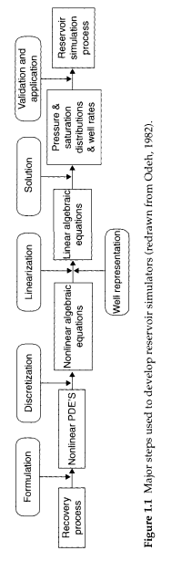
Figure 1: Major steps used to develop reservoir simulator Aziz & Settari, (1979).
The displacement process involving immiscible and miscible fluids is considerable importance in every aspect of subsurface engineering for energy and environmental applications requires in-depth understanding of multiphase ﬂow within heterogeneous porous media. Examples include enhanced hydrocarbon recovery, geologic carbon sequestration, nuclear waste storage, geothermal energy production, seasonal storage of natural gas in geologic formations, and gas hydrate formation in sediments. For immiscible two-phase fluids, the nature of fluid flow in a porous medium is different from that in the tube cell, unlike the tube cell, where the interfacial tension acts at a single interface, the capillary forces in a porous medium act on a multitude of microscopic interfaces, giving rise to a single dispersed interface at the macroscopic level. Additionally, the mobility of individual phases within the pore space is governed by the wettability properties of the porous medium. Therefore, the dynamics of immiscible and miscible displacements in porous media are represented by Darcy’s and advection-convection laws for each phase with an associated relative permeability and diffusion coefficient function respectively.
As stated earlier, numerical simulation of immiscible fluid displacement in subsurface porous media remains an important and challenging problem with application to oil-recovery processes and potential subsurface CO2 sequestration processes. However, it still now used as an essential tool for quantitative reservoir management in the oil and gas industry. It application have help improve petroleum production, design optimal development plans, understand reservoir features through history matching, and assess uncertainties associated with production decisions. In properly simulate fluid flow in the reservoir, the mathematical model, including the governing equations, initial and boundary conditions, is constructed shown in Figure 1. The governing equations are discretized in time and space, and the resulting systems of nonlinear algebraic equations must be solved at every time step. The pressure and saturation equations, which describe the transport of the fluid phases in space and time, are highly nonlinear. They are characterized by non-convex flux functions that can also be non-monotonic in the presence of strong capillary, viscous and buoyancy forces. The saturation field is strongly coupled to the phase velocities, which are in turn strongly dependent on the distribution of the phase pressures. In order to model immiscible processes in natural porous media efficiently, it is critical to deal effectively with the nonlinear coupling between flow (pressures and velocities) and transport (saturation). Thus, the objective of the project is the development of simple and efficient solution for the nonlinear system of equations that describe flow and transport in large-scale, heterogeneous reservoir models, considering viscous, buoyancy, and capillary effects.

LITERATURE-REVIEWS
Multiphase flow in porous media is a very active field of research subject, and full of great complexity since this type of problem arise in many practical situations in fluid dynamics, many of them linked to groundwater pollution, oil and gas recovery, or CO2 storage in geological formations, to name but a few, Higdon, 2013. The single-phase fluid flow through a porous medium is well characterized by Darcy’s law, and the main features of the subject have been well understood for over 150 years. By contrast, modeling multiphase flow remains an enormous technical challenge. A wide gap exists between the model equations used in industrial application and a fundamental understanding of detailed microscale physics. In the petroleum industry and in other technical applications, transport is modeled by postulating a multiphase generalization of Darcy’s law. Here, distinct pressures are defined in each constituent phase with the difference, called capillary pressure, determined by the interfacial tension, micropore geometry, and surface chemistry of the solid medium.
Because of the interest of multiphase flow in porous media, many relevant works have been developed to this aim, among which some classical reviews have been given by [Adler, H. Brenner, (1988), Bear, (1988), Wooding and Morel-Seytoux, (1976)]. It has often been said that all models are wrong, but some are useful, and this certainly holds true in the application of Darcy’s law with relative permeabilities to multiphase flow. In the first instance, Darcy’s law is linear, while the true governing equation is nonlinear as established by experiment and microscale analyses. The particular context of the latter works was focused on the field of mathematical modeling and numerical simulation of the underground flow of oil-water systems. through the porous media due to an existing connected network of pores and also to the presence of fractures in the geological medium. The most common mathematical models that represent this kind of problem are given by a system of parabolic partial differential equations where the unknowns are the pressure and saturation of the different phases involved in the process, namely the Black-Oil model by Trangenstein and Bell, (1989). Many of the simulation tools used to obtain the solution of the mathematical models use finite differences or finite element methods. Other formulations, based on finite volume methods and combinations of finite element and finite volume methods, are also available in the literature Mantica et al, (1998).
In petroleum reservoir engineering, waterflooding is the commonest technique used to maintain or improve oil production rate.When water is injected into the reservoir, oil is displaced toward the production wells in the situation of immiscible two-phase flow. The mechanism of immiscible displacements of two-phase fluids was studied extensively and a number of technical papers have been published. The special case of one-dimensional, incompressible, two-phase flow was theoretically investigated first by Buckley and Leverett in 1942. The Buckley and Leverett frontal displacement theory described a method for calculating saturation profiles when the effects of capillary pressure and gravity are neglected. However, the theory gained popularity in petroleum engineering because of its simplicity and accuracy. Since the appearance of the theory, numerical analysis was eagerly attempted to simulate the Buckley-Leverett problem.
Pioneering work on two-phase immiscible displacements in porous media can be attributed to the experiments of Engelberts and Klinkenberg, (1951); Chouke et al., (1959) and Peters and Flock, (1981). These investigators show that a significant amount of the resident fluid is bypassed due to a strong viscous fingering instability. A number of experimental studies have followed in order to understand the mechanism of viscous fingering and its dependence on the capillary number and the mobility ratio. The linearized stability problem is well understood for two-phase immiscible displacements. Viscous instability is governed by the mobility ratio across the Buckley Leverett shock. Both the growth rate and the most dangerous mode grow linearly with the capillary number, but while the growth rate again scales linearly with the mobility ratio, the most dangerous mode scales with the square root of the mobility ratio. Most of the experimental work referenced above predates the linear stability analysis and therefore does not provide a comparison with theory. The early numerical methods were simultaneous solution method (SS) and implicit pressure-explicit saturation solution (IMPES) by finite difference method. The analysis was then extended to the case which includes the effect of gravity, capillary pressure, fluid compressibility and aquifer compressibility. Aziz and Settari, (1979) clearly explained that as time progress during the numerical analysis by FDM, , the saturation becomes a multiple-valued function of the grid spacing. The Finite Element Method was also developed to the analysis of flow through porous media, and applied to the two-phase flow problems. There are common numerical difficulties in FDM and FEM that reverse changes in mobility factors in water and oil phases appear in the numerical computation process, which results in a convection-dominated situation. The upstream weighting for mobility factors is required to avoid these difficulties in both FDM and FEM.
Amir et al., 2006 proposed an accurate numerical simulations to investigated the fundamental physical mechanisms governing the nonlinear evolution of viscous instability. By employing a high-accuracy numerical method on a sufficiently refined grid, they practically eliminate the influence of numerical dispersion and resolve all relevant length and time scales in the flow. Hence, their novel numerical treatment of the highly nonlinear problem help us to understand the physical mechanisms associated with the evolution and interaction of viscous fingers. They utilize their previous linear stability analysis to determine the accuracy of our numerical method. A combination of spectral methods and high-order compact finite differences was used. They demonstrate that the early time dynamics are in good agreement with the linear stability theory, and show that viscous finger profiles are qualitatively similar to those observed in experiments. However, they did not attempt a detailed comparison due to the absence of information regarding the relative permeability functions associated with experiments. Their results show that while the instability is strongly influenced by the capillary number and the mobility ratio, it is qualitatively different from the miscible counterpart in terms of finger interaction mechanisms. Furthermore, the analysis of flows with density difference with gravity perpendicular to the mean flow direction, shows that the gravity tongue displays the phenomenon of “ridge instability.”
Abidulah and Shiegeo, 2013, did performed a Buckley-Leverett analysis based on the relative permeability data employed by Aziz and Settari, and then attempted the finite difference and the finite element analysis using the same physical data adopted in the Buckley-Leverett analysis. The numerical analysis was focused based on the method of IMPES, but special attention has been paid to the time step level in the pressure change in the numerical formulation

METHOD
Problem formulation
To achieve the objective of this project i.e describing fluid in a heterogeneous reservoir considering viscous, buoyancy, and capillary effects. A typical two-phase (oil/water) immiscible displacement problem from Erketin’s textbook is examined, however, some simplifications were made regarding grid orientation, well representation, boundary and initial conditions. The reservoir is a dipped and heterogeneous resservoir. Also, properties of the reservoir are pressure dependent. The Figure 2 below shows the 2-D uniform block centered grid implementation of the reservoir of interest. Other properties of the reservoir will be described later.
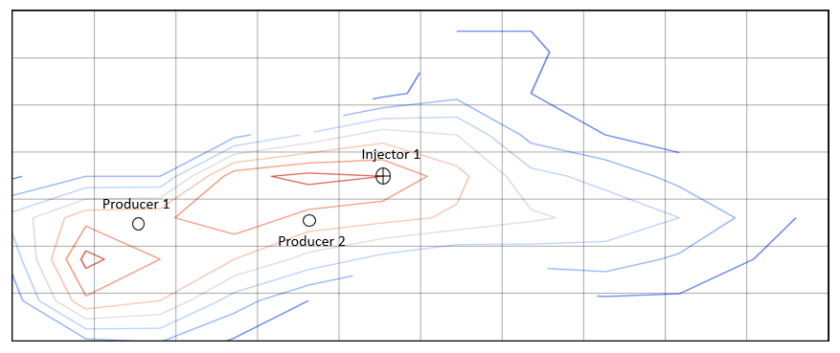
Figure 2: Reservoir A-1 schematic
Rock and Fluid Properties
In the section, we review relevant rock and fluid properties that influences the description of fluid flow in porous media. First we look at rock and fluid properties that are pressure dependent and rock-fluid interaction properties that are dependent on the fluid saturation.
Pressure dependent properties:
- Fluid properties
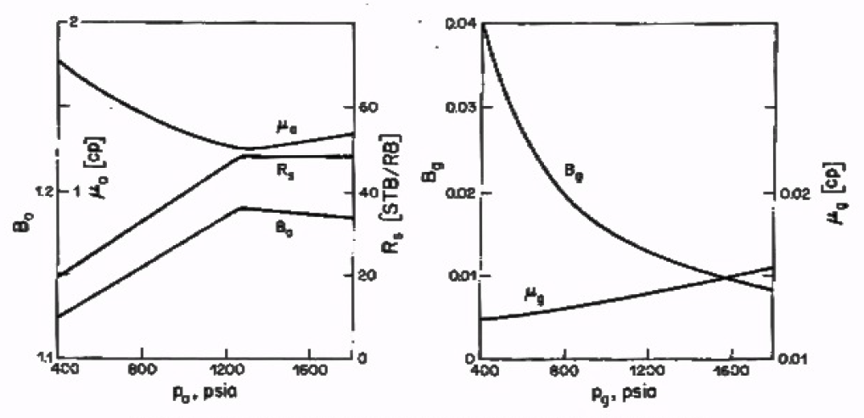Figure 3: Plot of pressure versus oil and gas fluid properties.

- Rock properties
The following relation show the dependence of porosity and permeability on pressure:
$$ϕ= {ϕ_{ref} (1+c}_{r}(P- P_{ref})$$
$$k= {k_{ref} (1+c}_{r}\left(P- P_{ref}\right) or k=f(ϕ)$$
Rock- fluid interaction properties
- Relative permeabilities
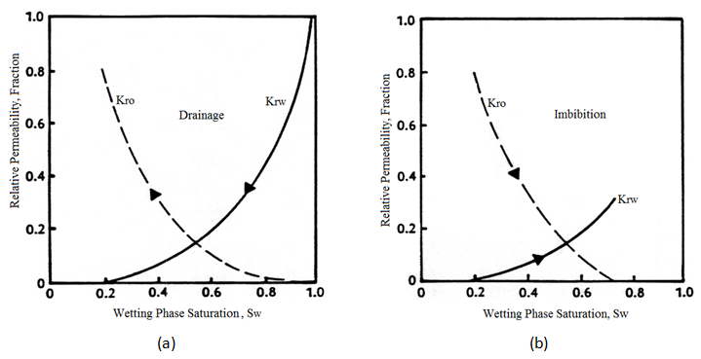
Figure 4: Relative permeabilities curves.

Brooks-Corey empirical models for oil/water system

$$n_{o} and n_{w} are corey exponents for oil and water$$

- Capillary Pressure
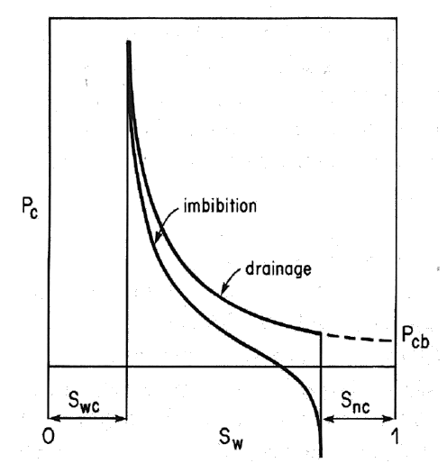
Figure 5: Capillary pressure curves, Aziz & Settari, (1979)

Van Genuchten Model:
- Drainage process:

- Imbibbiton Process

λ = pore size distribution, S_{w} = water saturation, S_{wcon} = connate or irreducible water saturation, S_{or} = residual oil saturation, P_{c} = capillary pressure, P_{e} = entry pressure.
Mathematical Model
We consider 2D nonlinear immiscible, slightly compressible, two-phase flow in porous media with capillary, gravity and heterogeniety. This is expressed as:
$$\frac{∂}{∂x}\left(\frac{β_{c} k_{x}k_{rl}A_{x}}{μ_{l}B_{l}} \left(∇Φ_{l}\right)\right)∆x+\frac{∂}{∂y}\left(\frac{β_{c}k_{y}k_{rl}A_{x}}{μ_{l}B_{l}} \left(∇Φ_{l}\right)\right)∆y - q_{l_{sc}} = \frac{V_{b}}{α_{c}}\frac{∂}{∂t}\left(\frac{ϕS_{l}}{B_{l}}\right)$$

$$\left(∇Φ\right)= \left(∇P_{l}-γ_{l}∇Z\right) is the potential$$

$$\frac{∂}{∂x}\left(\frac{β_{c} k_{x}k_{rl}A_{x}}{μ_{l}B_{l}} \left(∇P_{l}-γ_{l}∇Z\right)\right)∆x+\frac{∂}{∂y}\left(\frac{β_{c}k_{y}k_{rl}A_{x}}{μ_{l}B_{l}} \left(∇P_{l}-γ_{l}∇Z\right)\right)∆y - q_{l_{sc}} = \frac{V_{b}}{α_{c}}\frac{∂}{∂t}\left(\frac{ϕS_{l}}{B_{l}}\right)$$
Where $ϕ$ is the porosity of the medium. We use subscript l to denote the phases. $S_{l}$ is the saturation, $μ_{l}$ is the velocity, $B_{l}$ is formation volume factor, $P_{l}$ is the phase pressure, $γ_{l}$ is the phase specific gravity, $Z$ is the depth, $V_{b}$ = bulk volume, $k_{rl}= k_{rl}(S_{l})$ is the relative permeability, $q_{l_{sc}}$ is the source term, $β_{c} and α_{c}$ are constants.
Considering the fluid phases of oil and water only and assumning water as wetting phase and oil as non-wetting phase, the above flow equations for the two phases can be written:
$$\frac{∂}{∂x}\left(\frac{β_{c}k_{x}A_{x}k_{rw}}{μ_{w}B_{w}} \left(∇P_{w}-γ_{w}∇Z\right)\right)∆x+\frac{∂}{∂y}\left(\frac{β_{c}k_{x}A_{x}k_{rw}}{μ_{w}B_{w}} \left(∇P_{w}-γ_{w}∇Z\right)\right)∆y - q_{wsc} = \frac{V_{b}}{α_{c}}\frac{∂}{∂t}\left(\frac{ϕS_{w}}{B_{w}}\right)$$
$$\frac{∂}{∂x}\left(\frac{β_{c}k_{x}k_{ro}A_{x}}{μ_{o}B_{o}} \left(∇P_{o}-γ_{o}∇Z\right)\right)∆x+\frac{∂}{∂y}\left(\frac{β_{c}k_{x}k_{ro}A_{x}}{μ_{o}B_{o}} \left(∇P_{o}-γ_{o}∇Z\right)\right)∆y - q_{osc} = \frac{V_{b}}{α_{c}}\frac{∂}{∂t}\left(\frac{ϕS_{o}}{B_{o}}\right)$$
The phase saturation equation, which is a constraint on the sum of phase saturation, assuming water to be the wetting phase is:
$S_{o}+S_{w}=1 \left(saturation relation\right)$
$S_{o}=1-S_{w}$
$P_{cow}= P_{o}- P_{w}=f(S_{w}) \left(capillary pressure relation\right)$
$P_{w}= P_{o}- P_{cow}$
Substituting the $P_{w}= P_{o}- P_{cow}$ into the water phase and $S_{o}=1-S_{w}$ into the oleic phase flow equation respectively, we have, For water phase:
$$\frac{∂}{∂x}\left(\frac{β_{c}k_{x}k_{rw}}{μ_{w}B_{w}} \left(∇P_{o}-∇P_{cow}-γ_{w}∇Z\right)\right)∆x+\frac{∂}{∂y}\left(\frac{β_{c}k_{x}k_{rw}}{μ_{w}B_{w}} \left(∇P_{o}-∇P_{cow}-γ_{w}∇Z\right)\right)∆y- q_{wsc} = \frac{V_{b}}{α_{c}}\frac{∂}{∂t}\left(\frac{ϕS_{w}}{B_{w}}\right)$$
For oil phase:
$$\frac{∂}{∂x}\left(\frac{β_{c}k_{x}k_{ro}}{μ_{o}B_{o}} \left(∇P_{o}-γ_{o}∇Z\right)\right)∆x+\frac{∂}{∂y}\left(\frac{β_{c}k_{x}k_{ro}}{μ_{o}B_{o}} \left(∇P_{o}-γ_{o}∇Z\right)\right)∆y - q_{osc} = \frac{V_{b}}{α_{c}}\frac{∂}{∂t}\left(\frac{ϕS_{o}}{B_{o}}\right)$$
Relative permeabilities and capillary pressures are functions of water saturation, and formation volume factors, viscosities and porosity are functions of pressures. Rock and fluid properties as they are defined in a standard black oil model have been reviewed in the previous section.

Discretization of flow equations
We will use similar finite difference approximations for the two-phase equations as similar to that of the single phase flow.
Left side flow terms
Spatial dicretizaton of the LHS term for water phase yields,
$$\frac{∂}{∂x}\left(\frac{β_{c}k_{x}k_{rw}A_{x}}{μ_{w}B_{w}} \left(∇P_{o}-∇P_{cow}-γ_{w}∇Z\right)\right)∆x+\frac{∂}{∂y}\left(\frac{β_{c}k_{x}k_{rw}A_{x}}{μ_{w}B_{w}} \left(∇P_{o}-∇P_{cow}-γ_{w}∇Z\right)\right)∆y- q_{wsc}$$

$$T_{x{w }_{i+1/2, j} }\left(P_{{o }_{i+1 , j}}-P_{{o }_{i, j}}\right)+ T_{x{w }_{i-1/2, j} }\left(P_{{o }_{i+1 , j}}-P_{{o }_{i , j}}\right)-T_{x{w }_{i+1/2, j} }\left(P_{c{ow }_{i+1 , j}}-P_{c{ow }_{i , j}}\right)-T_{x{w }_{i-1/2, j} }\left(P_{c{ow }_{i-1 , j}}-P_{c{ow }_{i , j}}\right)- G_{x{w }_{i+1/2, j} }\left(Z_{ _{i+1 , j}}-Z_{ _{i , j}}\right)- G_{x{w }_{i-1/2, j} }\left(Z_{ _{i , j-1}}-Z_{ _{i , j}}\right) + T_{y{w }_{i , j+1/2} }\left(P_{{o }_{i , j+1}}-P_{{o }_{i, j}}\right)+ T_{y{w }_{i , j-1/2} }\left(P_{{o }_{i , j-1}}-P_{{o }_{i , j}}\right)-T_{y{w }_{i , j+1/2} }\left(P_{c{ow }_{i, j+1}}-P_{c{ow }_{i , j}}\right)-T_{y{w }_{i , j-1/2} }\left(P_{c{ow }_{i, j-1}}-P_{c{ow }_{i , j}}\right)- G_{y{w }_{i , j+1/2} }\left(Z_{ _{i+1 , j}}-Z_{ _{i , j}}\right)- G_{y{w }_{i , j-1/2} }\left(Z_{ _{i , j}}-Z_{ _{i , j-1}}\right)- q_{wsc i , j}$$
For oil phase:
$$\frac{∂}{∂x}\left(\frac{β_{c}k_{x}k_{ro}A_{x}}{μ_{o}B_{o}} \left(∇P_{o}-γ_{o}∇Z\right)\right)∆x+\frac{∂}{∂y}\left(\frac{β_{c}k_{x}k_{ro}A_{x}}{μ_{o}B_{o}} \left(∇P_{o}-γ_{o}∇Z\right)\right)∆y - q_{osc}$$
$$T_{x{o }_{i+1/2, j} }\left(P_{{o }_{i+1 , j}}-P_{{o }_{i, j}}\right)+ T_{x{o }_{i-1/2, j} }\left(P_{{o }_{i+1 , j}}-P_{{o }_{i , j}}\right) - G_{x{o }_{i+1/2, j} }\left(Z_{ _{i+1 , j}}-Z_{ _{i , j}}\right)- G_{x{o }_{i-1/2, j} }\left(Z_{ _{i , j-1}}-Z_{ _{i , j}}\right) + T_{y{o }_{i , j+1/2} }\left(P_{{o }_{i , j+1}}-P_{{o }_{i, j}}\right)+ T_{y{o }_{i , j-1/2} }\left(P_{{o }_{i , j-1}}-P_{{o }_{i , j}}\right)- G_{y{o }_{i , j+1/2} }\left(Z_{ _{i+1 , j}}-Z_{ _{i , j}}\right)- G_{y{o }_{i , j-1/2} }\left(Z_{ _{i , j}}-Z_{ _{i , j-1}}\right)- q_{osc i , j}$$
Interblock transmissibility treatment
From the above the transmissibility terms: $T_{x{w }_{i±1/2, j} }$, $T_{x{o }_{i±1/2, j} }$ , $T_{y{w }_{i , j±1/2} }$ , $T_{y{o }_{i , j±1/2} }$ , $G_{x{w }_{i±1/2, j} }$ , $G_{x{o }_{i±1/2, j} }$, $G_{y{w }_{i , j±1/2} }$ , $G_{y{o }_{i , j±1/2} }$ are treated as:
$$T_{x{w }_{i±1/2, j} }= \frac{β_{c}{ k}_{x} k_{rw}{ A}_{x}}{{Δx μ}_{w} B_{w}}=β_{c}{\left( \frac{k_{x}A_{x}}{Δx}\right)}_{ _{i±1/2, j}} . {\left( k_{rw}\right)}_{ _{i±1/2, j}} . {\left( \frac{1}{μ_{w} B_{w}}\right)}_{ _{i±1/2, j}}$$
$$T_{x{o }_{i±1/2, j} }= \frac{β_{c}{ k}_{x} k_{ro}{ A}_{x}}{{Δx μ}_{o} B_{o}}=β_{c}{\left( \frac{k_{x}A_{x}}{Δx}\right)}_{ _{i±1/2, j}} . {\left( k_{ro}\right)}_{ _{i±1/2, j}} . {\left( \frac{1}{μ_{o} B_{o}}\right)}_{ _{i±1/2, j}}$$
$$T_{y{w }_{i , j±1/2} }= \frac{β_{c}{ k}_{y} k_{rw}{ A}_{y}}{{Δy μ}_{w} B_{w}}=β_{c}{\left( \frac{k_{y}A_{y}}{Δy}\right)}_{ _{i , j±1/2,}} . {\left( k_{rw}\right)}_{ _{i , j±1/2}} . {\left( \frac{1}{μ_{w} B_{w}}\right)}_{ _{i , j±1/2}}$$
$$T_{y{o }_{i , j±1/2} }= \frac{β_{c}{ k}_{y} k_{ro}{ A}_{y}}{{Δy μ}_{o} B_{o}}=β_{c}{\left( \frac{k_{y}A_{y}}{Δy}\right)}_{ _{i , j±1/2,}} . {\left( k_{ro}\right)}_{ _{i , j±1/2}} . {\left( \frac{1}{μ_{o} B_{o}}\right)}_{ _{i , j±1/2}}$$
$$G_{x{l }_{i±1/2, j} }= {T_{xl }γ_{l}}_{{ }_{i±1/2, j}} { G}_{y{l }_{i , j±1/2} }= {T_{x }γ_{w}}_{ , j±1/2}$$
The geometric factors for the centered block grid can be obtained by:
$$G_{p}= β_{c}{\left( \frac{k_{x}A_{x}}{Δx}\right)}_{ _{i±1/2, j}}= β_{c} \frac{2 A_{x_{i}}k_{x_{i}}A_{{x }_{i±1}}k_{x_{i±1 }}}{A_{x_{i}}k_{x_{i}}{∆x}_{i±1}+ A_{{x }_{i±1}}k_{{x }_{i±1 }}{∆x}_{i}}$$
$$G_{p}= β_{c}{\left( \frac{k_{y}A_{y}}{Δy}\right)}_{ _{i , j±1/2}}= β_{c} \frac{2 A_{y_{i} }k_{y_{i }}A_{{y }_{i±1}}k_{y_{i±1 }}}{A_{y_{i}}k_{y_{i}} {∆y}_{i±1}+ A_{{y }_{i±1}}{ k}_{{y }_{i±1 }}{∆y}_{i}}$$
In this project, we assume $∆y= {∆y}_{i}= {∆y}_{i±1}$ , $A_{y_{i}}= A_{y_{i±1}}$and $∆x= {∆x}_{i}= {∆x}_{i±1}$ , $A_{x_{i}}= A_{x_{i±1}}$
For blocks of practical sizes in reservoir simulation, upstream mobilities or relative permeabilities of each phase are normally used, therefore the upstream selection of mobilities or relative permeabilities selection are:
$$k_{{rl }_{ _{i±1/2, j}}}=\left\{\begin{aligned}{ k}_{{rl}_{ _{i ± 1 , j}}} if Φ_{l_{ _{i±1 , j}}}≥ Φ_{l_{ _{i , j}}} \\ { k}_{{rl}_{ _{i , j}}} if Φ_{l_{ _{i±1 , j}}} < Φ_{l_{ _{i , j}}}\end{aligned}\right.$$
$$k_{{rl }_{ _{i , j±1/2,}}}=\left\{\begin{aligned}{ k}_{{rl}_{ _{i , j+1}}} if Φ_{l_{ _{i , j±1,}}}≥ Φ_{l_{ _{i , j}}} \\ { k}_{{rl}_{ _{i , j}}} if Φ_{l_{ _{ _{i , j±1,}}}} < Φ_{l_{ _{i , j}}}\end{aligned}\right.$$
$$where, l=w, o$$
$$Φ_{l_{ _{i±1 , j}}}= P_{l_{ _{i±1 , j}}}± γ_{l_{ _{i±1 , j}}}\left( Z_{i±1 , j}-Z_{i , j}\right)-P_{c i , j} ,$$
$$Φ_{l_{ _{i , j±1}}}= P_{l_{ _{i , j±1}}}± γ_{l_{ _{i , j±1 }}}\left( Z_{ _{i , j±1 }}-Z_{i , j}\right)- P_{c i , j}$$
$If no gravity term$
$$Φ_{l_{ _{i±1 , j}}}= P_{l_{ _{i±1 , j}}} , Φ_{l_{ _{i , j±1}}}= P_{l_{ _{i , j±1 , j}}}$$
Treatment of the fluid property term i.e viscosity, formation volume factor and specific gravity is done explicitly using the arithmetic averaging because of its weak nonlinearity that does not cause any severe stability problems..
$$f_{p}={\left( \frac{1}{μ_{l} B_{l}}\right)}_{ _{i±1/2 , j}}=\left(\frac{1}{{\overline{μ}}_{l} . {\overline{B}}_{l} }\right) , {f_{p}}^{*}= {\left( \frac{γ_{l}}{μ_{l} B_{l}}\right)}_{ _{i±1/2 , j}}=\left(\frac{{\overline{γ}}_{l}}{{\overline{μ}}_{l} . {\overline{B}}_{l} }\right)$$
$$f_{p}={\left( \frac{1}{μ_{l} B_{l}}\right)}_{ _{i±1/2 , j}}= \frac{{ ω}_{1}*{\left( \frac{1}{μ_{l} B_{l}}\right)}_{ _{i , j}} + { ω}_{2} *{\left( \frac{1}{μ_{l} B_{l}}\right)}_{ _{i±1 , j}}}{{ (ω}_{1}+ { ω}_{2})}$$
$$f_{p}={\left( \frac{1}{μ_{l} B_{l}}\right)}_{ _{i±1/2 , j}}= \frac{{ ω}_{1}*{\left( \frac{γ_{l}}{μ_{l} B_{l}}\right)}_{ _{i , j}} +{ ω}_{2}*{\left( \frac{γ_{l}}{μ_{l} B_{l}}\right)}_{ _{i±1 , j}}}{{ (ω}_{1}+ { ω}_{2})}$$
$${ ω}_{1}={\left(V_{b}ϕ\right)}_{i , j} and { ω}_{2}= {\left(V_{b}ϕ\right)}_{i±1 , j}$$
$$where, l=w, o$$
Repeat the same for properties in the y-direction.
Right side flow terms:
The right hand side of the oil equation may be expanded as follows:
$$\frac{V_{b}}{α_{c}}\frac{∂}{∂t}\left(\frac{ϕS_{o}}{B_{o}}\right)=\frac{V_{b}}{α_{c}} \left[\frac{ϕ}{B_{o}}\frac{∂S_{o}}{∂t}+ S_{o}\frac{∂}{∂t}\left(\frac{ϕ}{B_{o}}\right)\right]$$
Since the derivative part of the second term is identical to the right hand side of the one phase equation, we may write an approximation for this directly:
$$\frac{∂}{∂t}\left(\frac{ϕ}{B_{o}}\right)= \frac{ϕ}{{∆t}_{i}}{\left[\frac{c_{r}}{B_{o}}+ \frac{d(1/B_{o})}{dP_{o}}\right]}_{i , j} \left(P_{{o }_{i , j}}- {P_{{o }_{i , j}}}^{n}\right)$$
For the first term, we will replace oil saturation by water saturation, so that:
$$\frac{∂S_{w}}{∂t}=-\frac{∂S_{o}}{∂t}$$
Then we may use a standard backward approximation of the time derivative,
$${\left(\frac{ϕ}{B_{o}}\frac{∂S_{o}}{∂t}\right)}_{i , j}= -\frac{ϕ_{i , j}}{B_{o i, j }{∆t}_{i}}\left(S_{{w }_{i , j}}- {S_{{w }_{i , j}}}^{n}\right)$$
The complete difference form of the right hand side of the oil equation may thus be written as:
$$\frac{V_{b i , j}}{α_{c}}{\frac{∂}{∂t}\left(\frac{ϕS_{o}}{B_{o}}\right)}_{i , j}= \frac{1}{{∆t}_{i}}\left[{C_{poq}}_{i , j}\left(P_{{o }_{i , j}}- {P_{{o }_{i , j}}}^{n}\right)+{C_{swo}}_{i , j}\left(S_{{w }_{i , j}}- {S_{{w }_{i , j}}}^{n}\right)\right]$$
Where,
$$C_{poq i , j}= \frac{V_{b i , j} ϕ_{i,j}\left(1-S_{{w }_{i , j}}\right)}{α_{c}}{\left[\frac{c_{r}}{B_{o}}+ \frac{d(1/B_{o})}{dP_{o}}\right]}_{i , j}$$
$${C_{swo}}_{ i, j}= -\frac{V_{b i , j}}{α_{c}}\frac{ϕ_{i,j}}{B_{o i , j }}$$
For the water equation, a similar expansion is carried:
$$\frac{V_{b}}{α_{c}}\frac{∂}{∂t}\left(\frac{ϕS_{w}}{B_{w}}\right)= \frac{V_{b}}{α_{c}} \left[\frac{ϕ}{B_{w}}\frac{∂S_{w}}{∂t}+ S_{w}\frac{∂}{∂t}\left(\frac{ϕ}{B_{w}}\right)\right]$$
The second term in this expression may be expanded further, to yield:
$$\frac{∂}{∂t}\left(\frac{ϕ}{B_{w}}\right)= \frac{∂}{∂P_{w}}\left(\frac{ϕ}{B_{w}}\right)\frac{∂P_{w}}{∂t}= \frac{∂}{∂P_{w}}\left(\frac{ϕ}{B_{w}}\right)\left(\frac{∂P_{o}}{∂t}- \frac{∂P_{cow}}{∂t}\right)$$
Since capillary pressure is a function of water saturation only, we may write
$$\frac{∂P_{cow}}{∂t}= \frac{dP_{cow}}{dS_{w}} \frac{∂S_{w}}{∂t}$$
Using the one phase terms and standard difference approximations for the derivatives, the right side of the water equation becomes:
$$\frac{V_{b i , j}}{α_{c}}{\frac{∂}{∂t}\left(\frac{ϕS_{w}}{B_{w}}\right)}_{i , j}= \frac{1}{{∆t}_{i}} \left[{C_{pow}}_{i , j}\left(P_{{o }_{i , j}}- {P_{{o }_{i , j}}}^{n}\right)+{C_{sww}}_{ i, j}\left(S_{{w }_{i , j}}- {S_{{w }_{i , j}}}^{n}\right)\right]$$
Where,
$$C_{pow i , j}= \frac{V_{b i , j }ϕ_{i,j}{ S}_{{w }_{i , j}}}{α_{c}}{\left[\frac{c_{r}}{B_{w}}+ \frac{d(1/B_{w})}{dP_{w}}\right]}_{i , j}$$
$${C_{swo}}_{ i, j}= \frac{V_{b i , j} }{α_{c}}\frac{ϕ_{i,j} }{B_{w i,j }}-{\left(\frac{dP_{cow}}{dS_{w}}\right)}_{i , j}C_{pow i , j}$$
The three derivative terms appearing in the expressions above:
$${\left[\frac{d(1/B_{w})}{dP_{w}}\right]}_{i , j} {\left[\frac{d(1/B_{o})}{dP_{o}}\right]}_{i , j} {\left(\frac{dP_{cow}}{dS_{w}}\right)}_{i , j}$$
are all computed numerically for each time step based on the respective PVT and capillary pressure input tables to the model.
Combining the RHS and LHS terms of each phase:
Water equation:
$T_{x{w }_{i+1/2, j} }\left({P_{{o }_{i+1 , j}}}^{n+1}-{P_{{o }_{i, j}}}^{n+1}\right)+ T_{x{w }_{i-1/2, j} }\left({P_{{o }_{i-1 , j}}}^{n+1}-{P_{{o }_{i, j}}}^{n+1}\right)-T_{x{w }_{i+1/2, j} }\left({P_{c{ow }_{i+1 , j}}}^{n}-{P_{c{ow }_{i , j}}}^{n}\right)-T_{x{w }_{i-1/2, j} }\left({P_{c{ow }_{i-1 , j}}}^{n}-{P_{c{ow }_{i , j}}}^{n}\right)- G_{x{w }_{i+1/2, j} }\left(Z_{ _{i+1 , j}}-Z_{ _{i , j}}\right)- G_{x{w }_{i-1/2, j} }\left(Z_{ _{i , j-1}}-Z_{ _{i , j}}\right) + T_{y{w }_{i , j+1/2} }\left({P_{{o }_{i , j+1}}}^{n+1}-{P_{{o }_{i, j}}}^{n+1}\right)+ T_{y{w }_{i , j-1/2} }\left({P_{{o }_{i , j-1}}}^{n+1}-{P_{{o }_{i, j}}}^{n+1}\right)-T_{y{w }_{i , j+1/2} }\left({P_{c{ow }_{i, j+1}}}^{n}-{P_{c{ow }_{i , j}}}^{n}\right)-T_{y{w }_{i , j-1/2} }\left({P_{c{ow }_{i, j-1}}}^{n}-{P_{c{ow }_{i , j}}}^{n}\right)- G_{y{w }_{i , j+1/2} }\left(Z_{ _{i+1 , j}}-Z_{ _{i , j}}\right)- G_{y{w }_{i , j-1/2} }\left(Z_{ _{i , j}}-Z_{ _{i , j-1}}\right)+ {q_{wsc i , j}}^{n}= \frac{1}{{∆t}_{i}} \left[{C_{pow}}_{i, j}\left({P_{{o }_{i , j}}}^{n+1}- {P_{{o }_{i , j}}}^{n}\right)+{C_{sww}}_{i, j}\left({S_{{w }_{i , j}}}^{n+1}- {S_{{w }_{i , j}}}^{n}\right)\right]$
Oil equation:
$T_{x{o }_{i+1/2, j} }\left({P_{{o }_{i+1 , j}}}^{n+1}-{P_{{o }_{i, j}}}^{n+1}\right)+ T_{x{o }_{i-1/2, j} }\left({P_{{o }_{i-1 , j}}}^{n+1}-{P_{{o }_{i, j}}}^{n+1}\right) - G_{x{o }_{i+1/2, j} }\left(Z_{ _{i+1 , j}}-Z_{ _{i , j}}\right)- G_{x{o }_{i-1/2, j} }\left(Z_{ _{i , j-1}}-Z_{ _{i , j}}\right) + T_{y{o }_{i , j+1/2} }\left({P_{{o }_{i+1 , j}}}^{n+1}-{P_{{o }_{i, j}}}^{n+1}\right)+ T_{y{o }_{i , j-1/2} }\left({P_{{o }_{i-1 , j}}}^{n+1}-{P_{{o }_{i, j}}}^{n+1}\right)- G_{y{o }_{i , j+1/2} }\left(Z_{ _{i+1 , j}}-Z_{ _{i , j}}\right)- G_{y{o }_{i , j-1/2} }\left(Z_{ _{i , j}}-Z_{ _{i , j-1}}\right)- q_{osc i , j}= \frac{1}{{∆t}_{i}}\left[{C_{poq}}_{i , j}\left({P_{{o }_{i , j}}}^{n+1}- {P_{{o }_{i , j}}}^{n}\right)+{C_{swo}}_{i , j}\left({S_{{w }_{i , j}}}^{n+1}- {S_{{w }_{i , j}}}^{n}\right)\right]$
Solution by IMPES method
In the equations above, oil pressure, P_{oi} , and water saturation, S_{wi} , are the primary variables, and unknowns to be solved for. All the coefficients in the equations, transmissibilities as well as storage coefficients, are functions of these unknowns. In addition, the capillary pressures on the left side of the water equation are functions of saturation. Thus, a solution method is needed that either iterates on the solution and updates coefficients and capillary pressures until convergence is reached, or some other method for estimating the coefficients and the capillary pressures. IMPES is a simple method, but one that is still being used quite extensively today.
Boundary and Initial Conditions
The boundary conditions are typically either (a) Neumann (constan fluxt or “no flux”), or (b) Dirichlet (constant pressure). If the boundary conditions are Neumann (constant flux), the constant flux term value can be substituted (in standard volume units) into the source vector, Q. For Dirichlet boundary, we add 2T_{l} and 2T_{l}P_{B} to the transmissibility matrix and source vector, Q respectively.
In this work, we asuumed a constant flux (zero flux) boundary for the right, left, top and bottom gridblock.

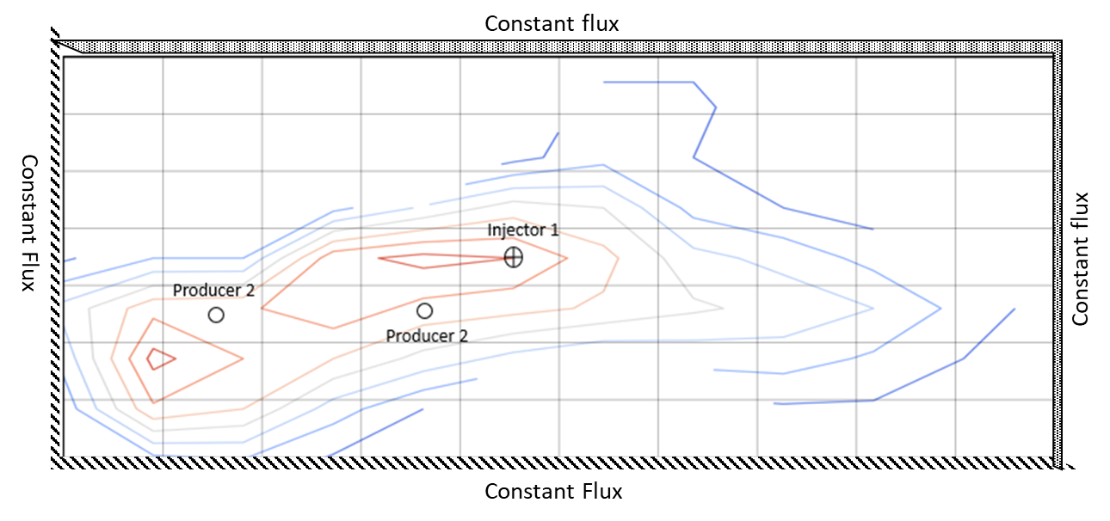
Figure 6: Assumed boundary conditions

Initial pressure of reservoir blocks either determined using the depth of the grid blocks and specific gravity of the fluid or as a constant value.
$$P_{{l }_{i , j} }\left(z, t=0\right)= P_{{l }_{ref}}+ \left(Z_{i , j }- Z_{ref }\right)γ_{l_{i , j}}$$
$$P_{c }=P_{nw }- P_{w }$$
From the text example, at the reference depth, initial oil pressure and initial water saturation are 7000 psia and 0.5 for all gridblock. For production and injection well in any gridblock, constant bottom hole pressure production and constant water injection rate is assumed.
Constant water injection rate
For a constant well rate of at surface conditions, which is the most common well rate specification. This is the simplest condition to handle, as a water rate term is already included in the water equation. Thus, for a constant surface water injection rate of Q_{wi} (positive) in a well in grid block i, j:
$${q_{{w }_{i , j}}}^{n}=5.615* {Q_{{w }_{i , j}}}^{n} scf/day$$
If the well is specified to have a constant well rate of at reservoir conditions, the per volume rate becomes:
$${q_{{w }_{i , j}}}^{n}=\frac{5.615* {Q_{{w }_{i , j}}}^{n}}{{B_{{w }_{i , j}}}^{n}} {ft}^{3}/day$$
Constant bottom hole pressure production
For the oil equation, this condition is handled as for the constant water injection rate. Thus, for a constant surface oil production rate of q_{oi} (negative) in a well in grid block i, j:
$$q_{l_{sc i , j}}=\frac{-2πβ_{c}k_{H}h ({p_{i , j }}^{n+1}-p_{wf})}{{(μB)}_{l i , j} \left[\log\left(\frac{r_{eq}}{r_{w}}\right)+s-F\right]}$$
Where req isequivalant wellbore radius, defined by Peaceman et al., as:
$$r_{eq}= 0.28 \frac{{\left(\left[{\left(\frac{k_{y}}{k_{x}}\right)}^{0.5}{∆x}^{2}\right]+\left[{\left(\frac{k_{x}}{k_{y}}\right)}^{0.5}{∆y}^{2}\right]\right)}^{0.5} }{{\left(\frac{k_{y}}{k_{x}}\right)}^{0.25}+{\left(\frac{k_{x}}{k_{y}}\right)}^{0.25}}$$
$$k_{H}= \sqrt{k_{x} k_{y}}$$
Also, s = skin factor, rw = wellbore radius, k = geometric permeabilty, $μB$ = phase viscosity and formation volume factor, F is 0.5 - steady state and 0.75 for psuedosteady state.
In short form, we can represent the above as:
$$q_{l_{sc i , j}}=J_{i , j} ({p_{i , j }}^{n+1}-p_{wf})$$
IMPES pressure solution
Since water saturation only appear as S_{wi} on the right sides of the two equations, they may be combined to eliminate water saturation completely as an unknown from the equations. Thus, we may obtain the implicit pressure solution, taking the following notations as:
$${\left(-\frac{d_{22}}{d_{12}}\right)}_{i , j}=\frac{{C_{swo}}_{i , j}}{{C_{sww}}_{i , j}}$$
$C_{i , j}=\left(-\frac{d_{22}}{d_{12}}\left[T_{x{w }_{i+1/2, j} }+ { T}_{x{w }_{i-1/2, j} }+{ T}_{y{w }_{i , j+1/2} }+ T_{y{w }_{i , j-1/2} }\right] + T_{x{o }_{i+1/2, j} }+ T_{x{o }_{i-1/2, j} }+ T_{y{o }_{i , j+1/2} }+ T_{y{o }_{i , j-1/2} }\right)$
$E_{i+1 , j}= -{\frac{d_{22}}{d_{12}} T}_{x{w }_{i+1/2, j} }+ T_{x{o }_{i+1/2, j} }$
$W_{i-1 , j}= -\frac{d_{22}}{d_{12}} T_{x{w }_{i-1/2, j} }+ T_{x{o }_{i-1/2, j} }$
$N_{i , j+1}= {-\frac{d_{22}}{d_{12}} T}_{y{w }_{i , j+1/2} }+ T_{y{o }_{i , j+1/2} }$
$S_{i , j-1}= {-\frac{d_{22}}{d_{12}} T}_{y{w }_{i , j-1/2} }+ T_{y{o }_{i , j-1/2} }$
$D_{i , j}=\left(-\frac{d_{22}}{d_{12}} . d_{11} + d_{21} \right)$
$C_{g i , j}=\left(-\frac{d_{22}}{d_{12}}\left[G_{x{w }_{i+1/2, j} }+ { G}_{x{w }_{i-1/2, j} }+{ G}_{y{w }_{i , j+1/2} }+ { G}_{y{w }_{i , j-1/2} }\right]+ G_{x{o }_{i+1/2, j} }+ G_{x{o }_{i-1/2, j} }+ G_{y{o }_{i , j+1/2} }+ G_{y{o }_{i , j-1/2} }\right)$
$E_{g i+1 , j}= {-\frac{d_{22}}{d_{12}} G}_{x{w }_{i+1/2, j} }+ T_{x{o }_{i+1/2, j} }$
$W_{g i-1 , j}= -\frac{d_{22}}{d_{12}} G_{x{w }_{i-1/2, j} }+ T_{x{o }_{i-1/2, j} }$
$N_{g i , j+1}= {- \frac{d_{22}}{d_{12}} G}_{y{w }_{i , j+1/2} }+ T_{y{o }_{i , j+1/2} }$
$S_{g i , j-1}= {-\frac{d_{22}}{d_{12}} G}_{y{w }_{i , j-1/2} }+ T_{y{o }_{i , j-1/2} }$
$C_{p i , j}=\left(-\frac{d_{22}}{d_{12}}\left[T_{x{w }_{i+1/2, j} }+ { T}_{x{w }_{i-1/2, j} }+{ T}_{y{w }_{i , j+1/2} }+ T_{y{w }_{i , j-1/2} }\right]+ T_{x{o }_{i+1/2, j} }+ T_{x{o }_{i-1/2, j} }+ T_{y{o }_{i , j+1/2} }+ T_{y{o }_{i , j-1/2} }\right)$
$E_{p i+1 , j}= {-\frac{d_{22}}{d_{12}} T}_{x{w }_{i+1/2, j} }$
$W_{p i-1 , j}= -\frac{d_{22}}{d_{12}} T_{x{w }_{i-1/2, j} }$
$N_{p i , j+1}= { -\frac{d_{22}}{d_{12}} T}_{y{w }_{i , j+1/2} }$
$S_{p i , j-1}= {-\frac{d_{22}}{d_{12}} T}_{y{w }_{i , j-1/2} }$
$Q_{ i , j} =q_{osc i , j}+ {-\frac{d_{22}}{d_{12}} q}_{wsc i , j}$
In the IMPES method, the key lies in the approximation of coefficients and capillary pressures. It simply evaluates these coefficients and capillary pressures at time level n , and thus enable us to solve for pressures and saturations without having to iterate on the solution. Thus, the following assumptions are made:
${T_{xo}}^{n} , {T_{xw}}^{n} , {C_{po}}^{n} , {C_{pw}}^{n} , {T_{xo}}^{n} , {T_{xw}}^{n} , {P_{cow}}^{n} at previous time step$
Having made these approximations, the equations in the final matrix form becomes:
Phase Mass Balances in short-hand
All of the “d’s” vary from block-to-block and also are functions of time because S_{w}, etc. vary with space and time.
Overall Mass Balance found by adding water and oil balances
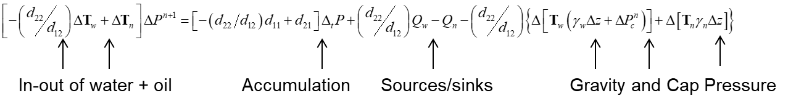

Expanding out the Transmissibility terms
IMPES saturation solution
Having obtained the oil pressures above, we need to solve for water saturations using either the oil equation or the water equation. In the following we will use the oil equation for this purpose:
${S_{{w }_{i , j}}}^{n+1}= {S_{{w }_{i , j}}}^{n}+\frac{{∆t}_{i}}{{C_{swo}}_{i , j}} \left[T_{x{o }_{i+1/2, j} }\left({P_{{o }_{i+1 , j}}}^{n+1}-{P_{{o }_{i, j}}}^{n+1}\right)+ T_{x{o }_{i-1/2, j} }\left({P_{{o }_{i-1 , j}}}^{n+1}-{P_{{o }_{i, j}}}^{n+1}\right) - G_{x{o }_{i+1/2, j} }\left(Z_{ _{i+1 , j}}-Z_{ _{i , j}}\right)- G_{x{o }_{i-1/2, j} }\left(Z_{ _{i , j-1}}-Z_{ _{i , j}}\right) + T_{y{o }_{i , j+1/2} }\left({P_{{o }_{i+1 , j}}}^{n+1}-{P_{{o }_{i, j}}}^{n+1}\right)+ T_{y{o }_{i , j-1/2} }\left({P_{{o }_{i-1 , j}}}^{n+1}-{P_{{o }_{i, j}}}^{n+1}\right)- G_{y{o }_{i , j+1/2} }\left(Z_{ _{i+1 , j}}-Z_{ _{i , j}}\right)- G_{y{o }_{i , j-1/2} }\left(Z_{ _{i , j}}-Z_{ _{i , j-1}}\right)- q_{osc i , j}- \frac{{C_{poq}}_{i , j}}{{∆t}_{i}}\left({P_{{o }_{i , j}}}^{n+1}- {P_{{o }_{i , j}}}^{n}\right)\right]$

$${S_{w}}^{n+1}= {S_{w}}^{n}+ {d_{12}}^{-1} \left[-d_{11}\left(P^{n+1}-P^{n}\right)-T_{w}\left(P^{n+1}- γ_{w} z- {P_{c}}^{n}\right)+ Q_{w}+ J_{w}\left(P_{wf}-P\right)\right]$$

RESULTS
The A-1 reservoir was used in the numerical simulation of two phase (oil/water) immiscible displacement. The summary of the data is presented below, however detailed description of rock, fluid and rock-interaction properties are presented in Erketin’s textbook.
Initial conditions
P_{oi} = 7000psia, S_{wi} = 0.5 all the same for all gridblocks

Reservoir Properties
L = 1200 ft, W = 600 ft, h = 200 ft, poro = varies (average ~0.214)
Kx = varies (average ~279.6 mD), Ky = 0.8*Kx, Kz = 1*Kx
c_{f} = 5.9E-06 psi⁻¹, T= 100 °F

Fluid Properties
ρ_{stock tank oil} = 52.4 lb/ft³, ρ_{water phase}= 62.4 lb/ft³, SG_{gas phase} = 0.6144,
P_{b} = 502.505 psi m_{w,sat} = m_{w,undersat} = 0.52 cp, m_{o,sat} = 0.918 cp,
c_{w} = 1.0 E-06 psi⁻¹, c_{o} = 5.0 E-06 psi⁻¹ P_{ref} = P_{oi} = 7000 psi,
B_{w,} (P)= 1.0 / [1.0 + c_{o} (p -14.7)] mu_{w,} (P)= 0.52 ( constant)
B_{w,} (P)= 1.0 / [1.0 + c_{w} (p -14.7)] mu_{o,} (P)= 0.981 - 3.73E-05 * P + 5.0E-09 * P ²
rho_{w,} (P)= rhwsc / B_{w} rho_{o,} (P)= rhosc / B_{o}

Well Properties
Q_inj (well 1) = 250 stb/day (Water only), Q_prod2 = 5300 psi (BHP),
Q_prod2 = 5300 psi (BHP), r_{w} = 0.25 feet, s = 0
Numerical Properties
NX = 9, NY = 12, dt = 1 day

Figure 7-14 show the graphical representation plot of the simulation results for pressure and saturation at 0, 100, 200 and 300 days respectively.
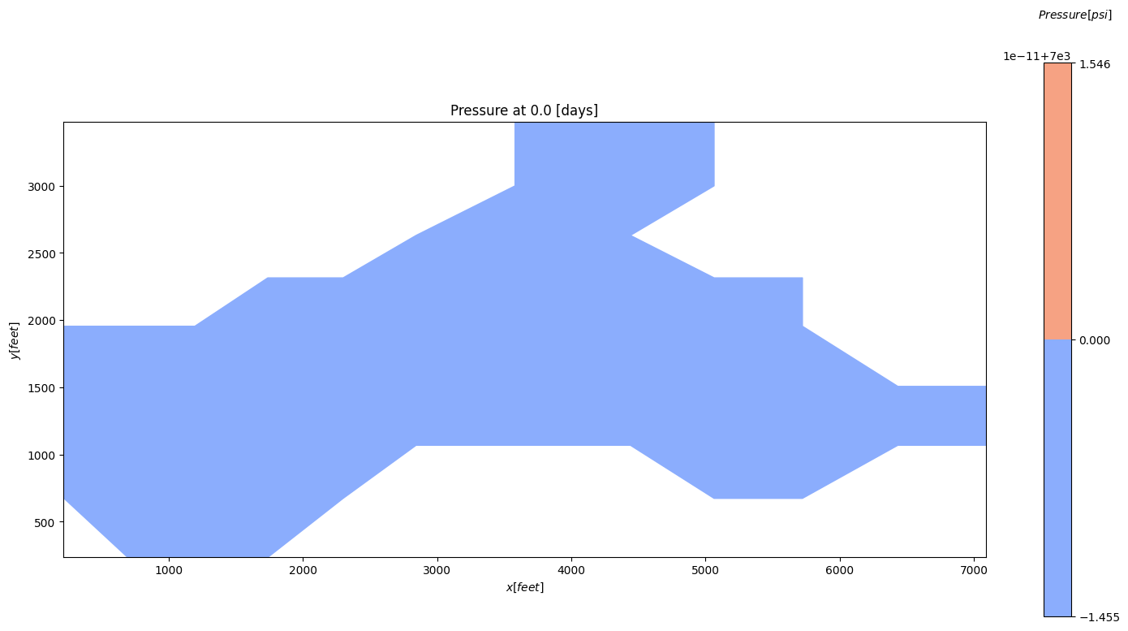
Figure 7: Pressure map at 0.0 days.

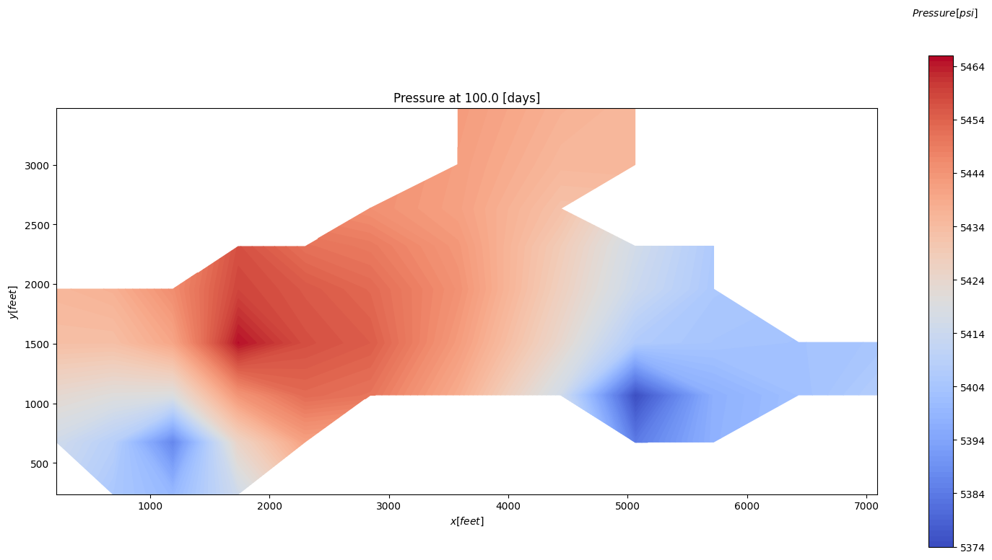
Figure 8: Pressure map at 100 days
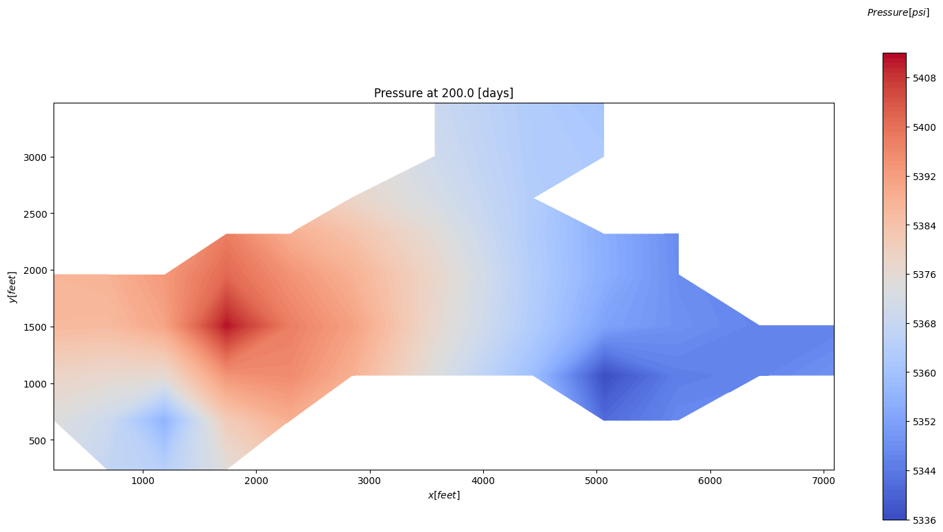
Figure 9: Pressure map at 200 days.

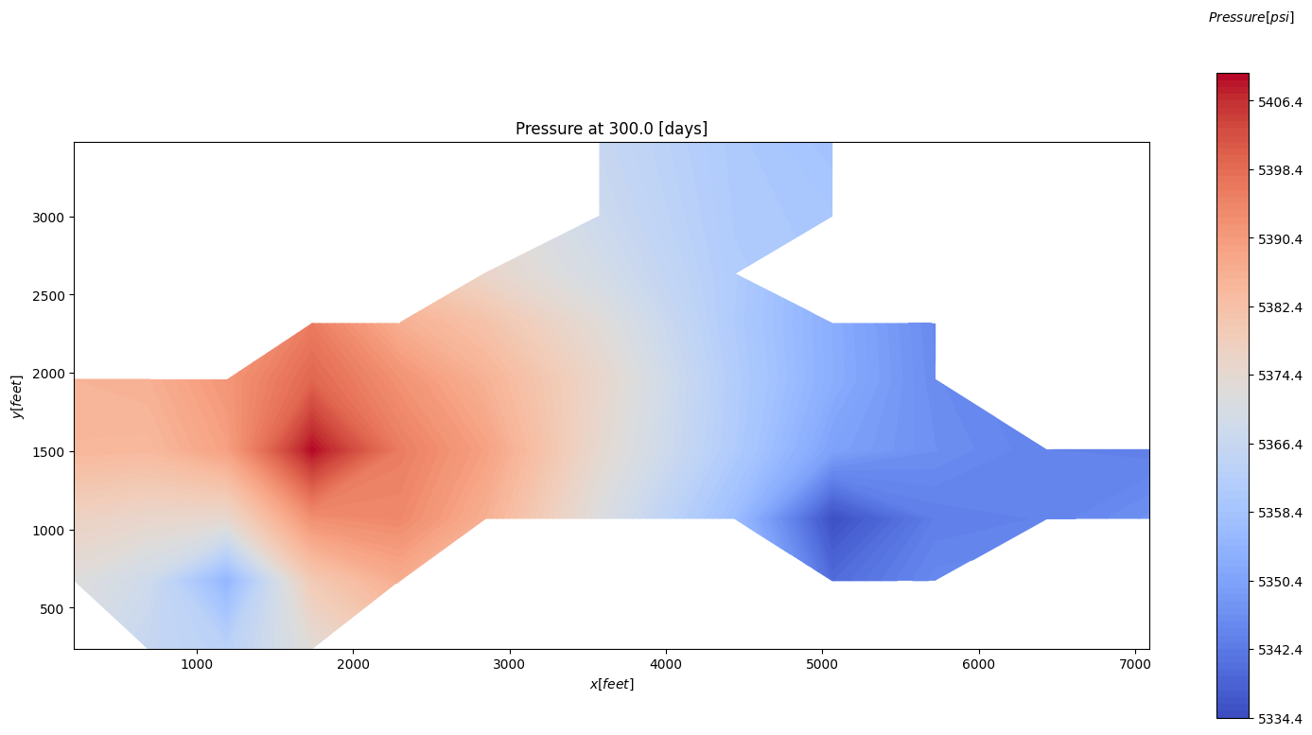
Figure 10: Pressure map at 300 days.
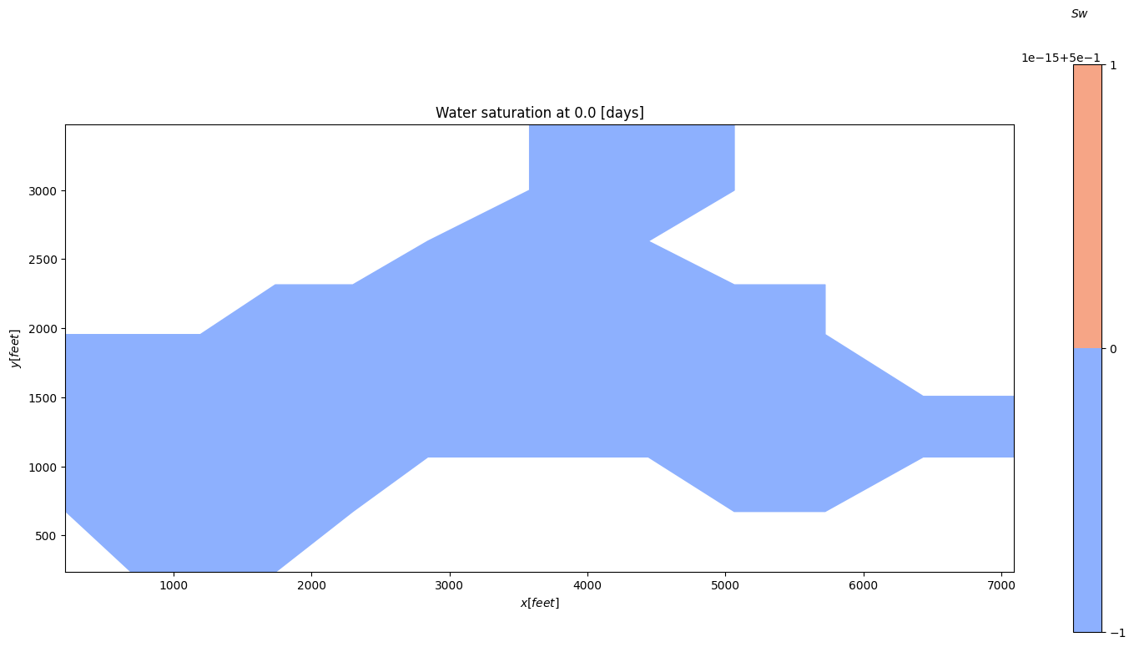
Figure 11: Water saturation at 0.0 days, (S_{wi} = 0.5).

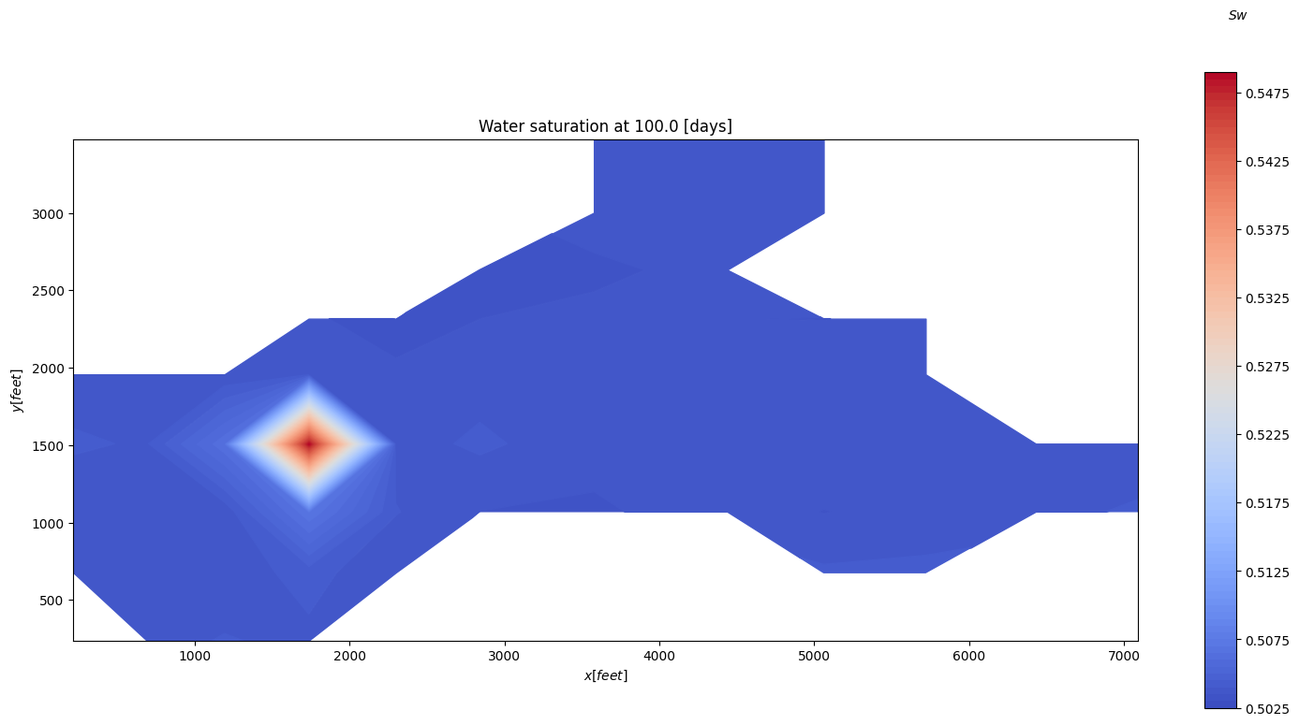
Figure 12: Water saturation at 100 days.
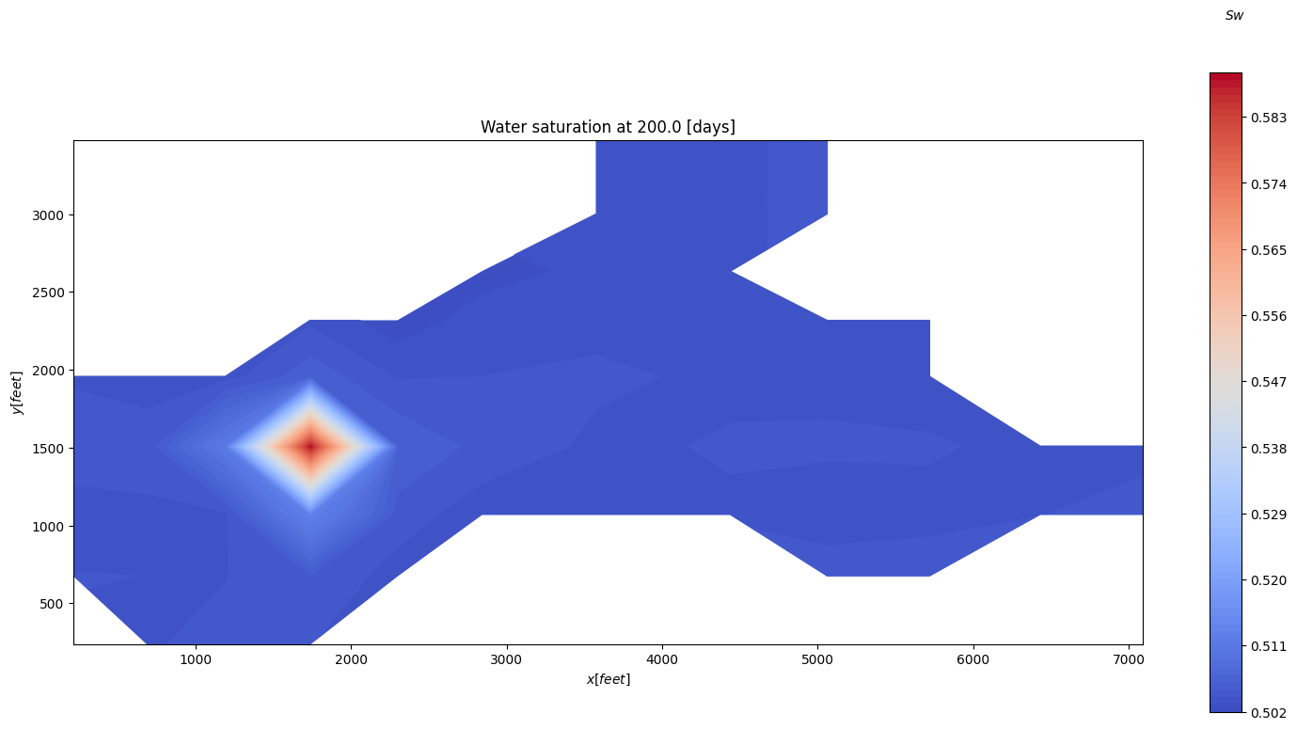
Figure 13: Water saturation at 200 days.

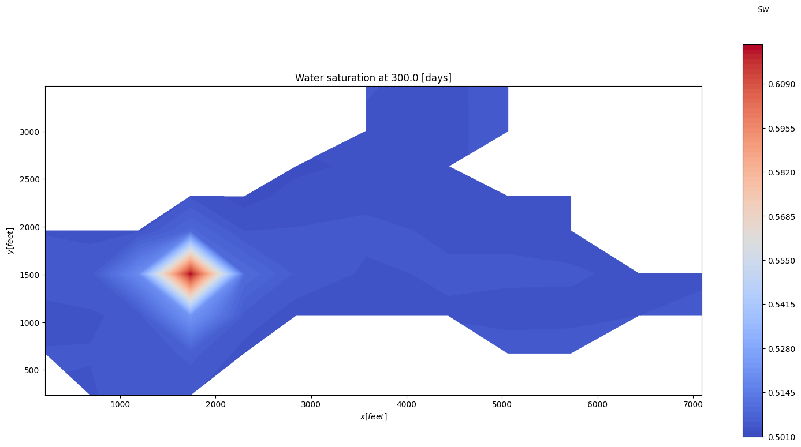
Figure 14: Water saturation at 300 days.

Next, the bottom hole pressure profile and injection/production rate profile from well 1, 2 and are also displayed in Figure 15-18.

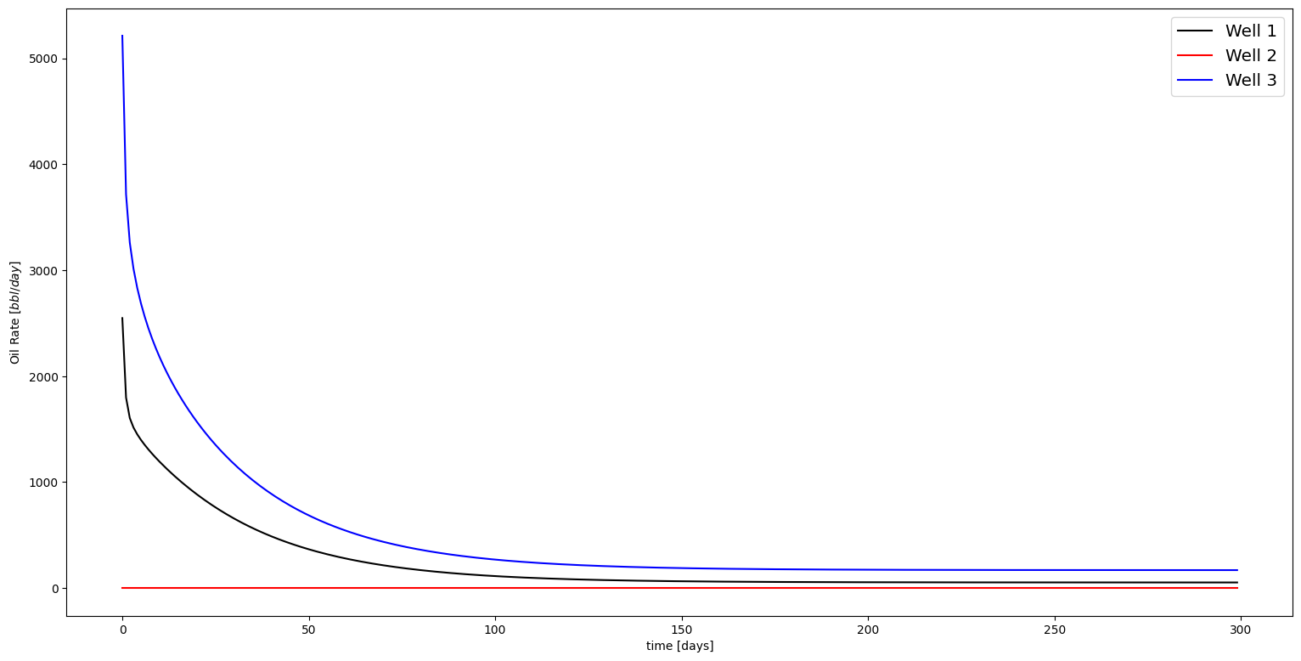
Figure 15: Oil rate profile for the wells.

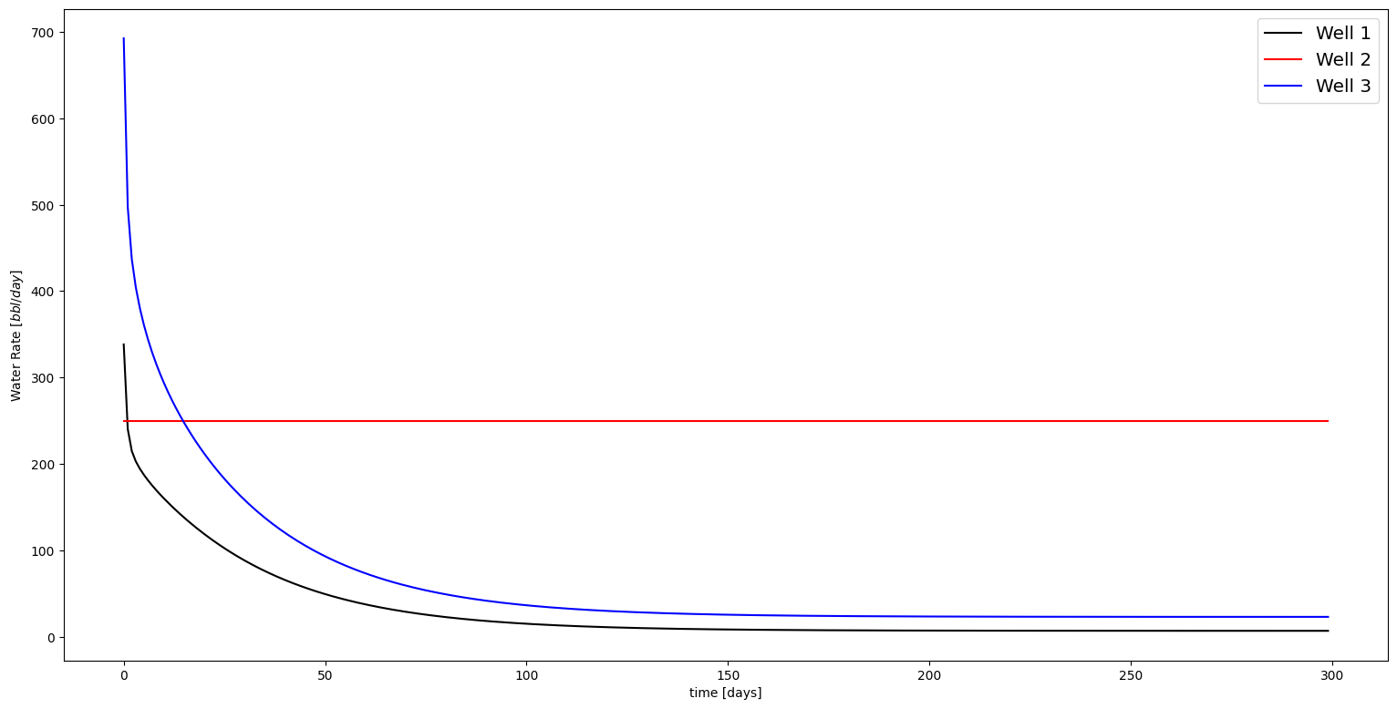
Figure 16: Water rate profile for the wells.

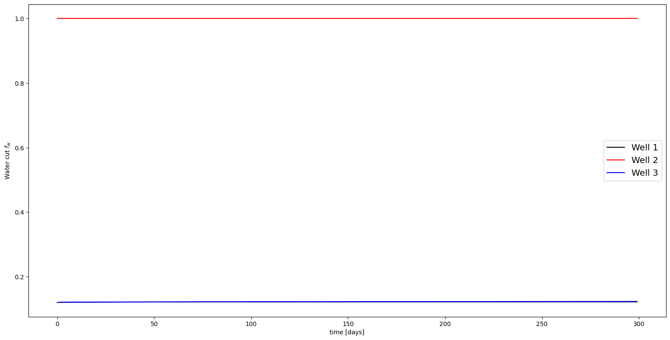
Figure 17: Water cut profile for the wells.

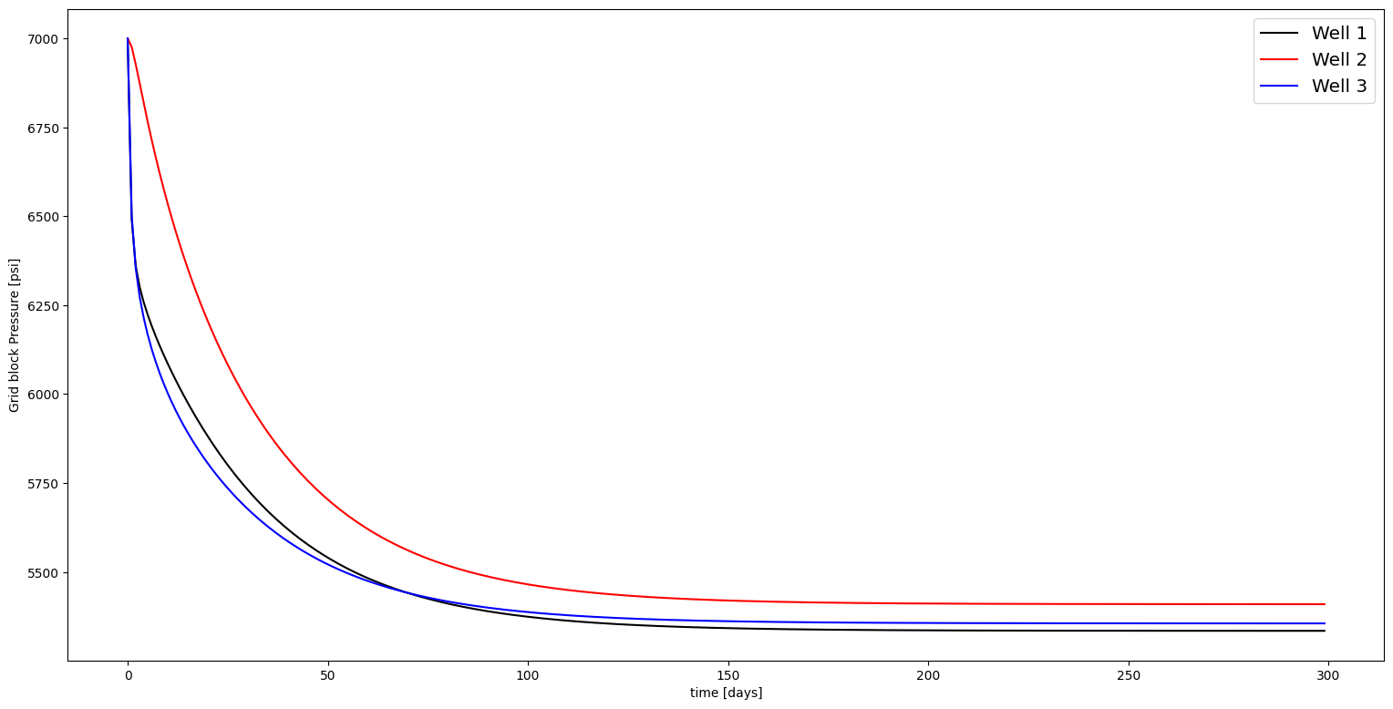
Figure 18: Gridblock pressure profile for the wells.

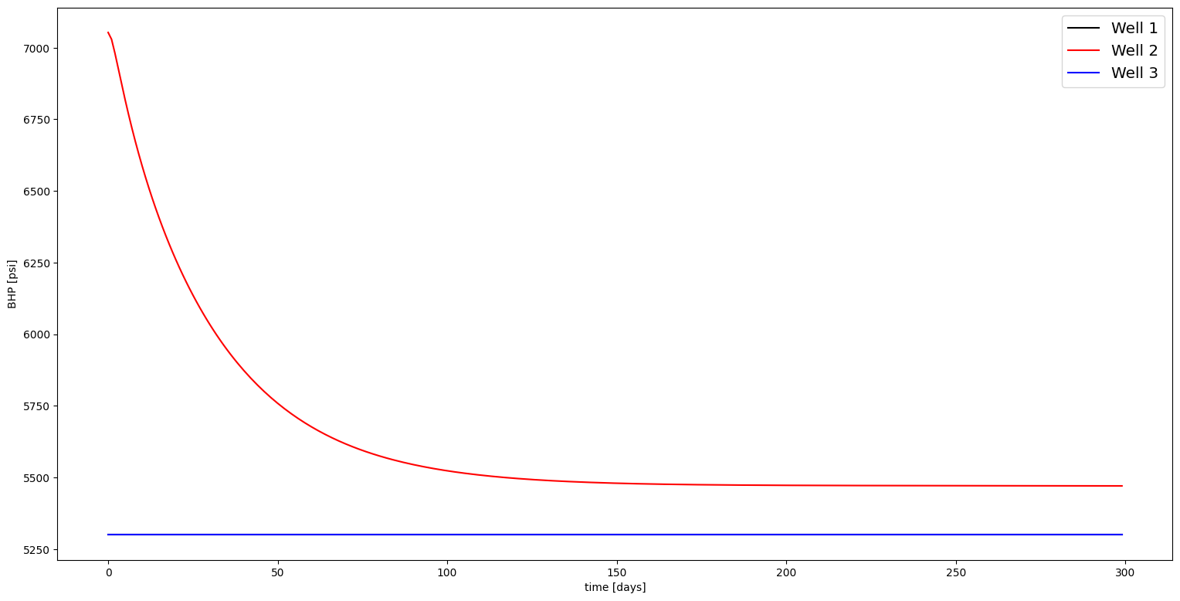
Figure 19: Bottom hole pressure profile for the wells.

References
- ] K. Aziz, A. Settari, Petroleum reservoir simulation, Elsevier Applied Science, 1979.
- J. Bear, Dynamics of Fluids in Porous Media Wiley, New York, 1972.
- P. M. Adler, H. Brenner; Multiphase flow in porous media, Annual Review of Fluid Mechanics 20 (1988), no. 1, 35–59.
- Wooding, R. A. & Morel-Seytoux, H. J. 1976 Multiphase fluid flow through porous media. Annu. Rev. Fluid Mech. 8, 233–274.
- Buckley, S.E. and Leverett, M.C. (1942), Mechanism of Fluid Displacement in Sands, Transactions AIME, Vol.146, pp.107-116.
- W. F. Engelberts and L. J. Klinkenberg, “Laboratory experiments on the displacement of oil by water from packs of granular material,” in Proceedings of the Third World Petroleum Congress, The Hague, 1951, Vol. II, p. 544.
- P. van Meurs, “Use of transparent three-dimensional models for studying the mechanism of flow processes in oil reservoirs,” Trans. AIME 210, 295 1957.
- R. L. Chouke, P. van Meurs, and C. van Der Poel, “The instability of slow, immiscible, viscous liquid-liquid displacements in permeable media,” Trans. AIME 216, 188 1959.
- E. J. Peters and D. L. Flock, “The onset of instability during two-phase immiscible displacements in porous media,” SPE J. 21, 249 1981.
- J. Kleppe; Reservoir simulation lecture notes, 2014.
- S. Mantica L. Bergamaschi and G. Manzini; A mixed finite element–finite volume formulation of the black-oil model, SIAM Journal on Scientific Computing 20 (1998), no. 3, 970–997.
- J. Trangenstein, J. Bell; Mathematical structure of the black-oil model for petroleum reservoir simulation, SIAM Journal on Applied Mathematics 49 (1989), no. 3, 749–78.

